https://www.e-billexpress.com/ebpp/BristolCT/Login/Index
*Online payments made before 8:00 p.m. will be available in your account the next business day*
Select Pay Now
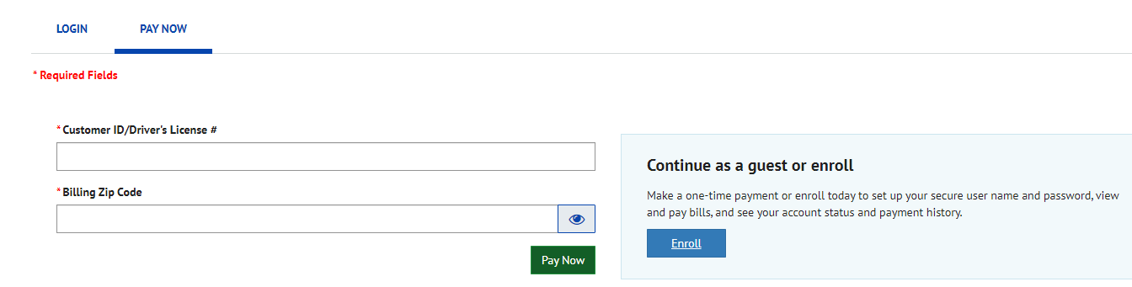
To check out as a guest, enter your driver’s license number and billing zip code. Please be aware that the driver’s license number must be entered correctly, and must belong to the account holder on file. If you wish to create an account, click Enroll. You may also create an account after you submit your payment. Please remember that any old user names or passwords will not work.

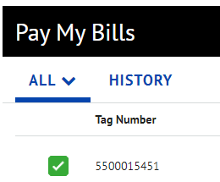
Click the box next to your permit number so there’s a green check mark

To check your balance and expiration date, click the magnifying glass icon next to Payment Code
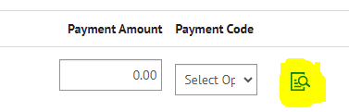

View your permit number, balance, and expiration date.

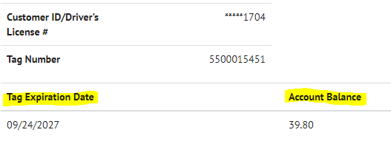

Click Close to return to the payment center. If you do not wish to make a payment, you may exit.

Type the amount of your payment in Payment Amount. Select the type of payment (Add Funds or Permit Renew) in Payment Code. Renewals are $40. There is no minimum amount for adding funds. Please be aware you need $25.00 in funds to access the Transfer Station.
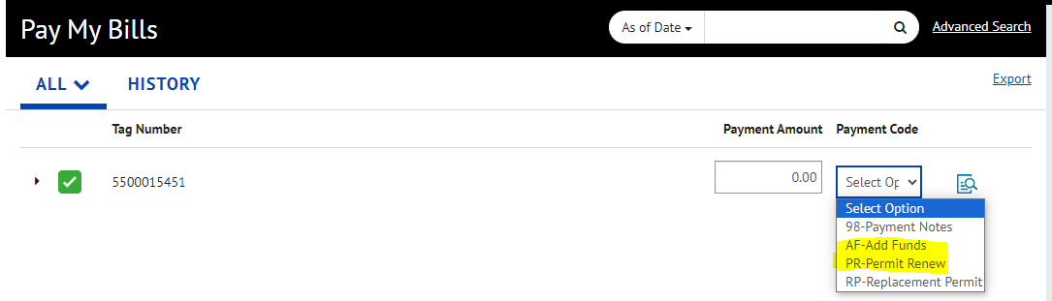
In Payment Summary, click Enter next to Payment Method to add a new payment method. If you have created an account and saved your payment method, you can choose your saved payment method from the drop-down. Click Continue to Payment.
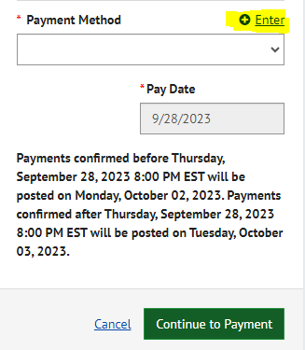
Review your information. Fill out all required fields. Click Make Payment. 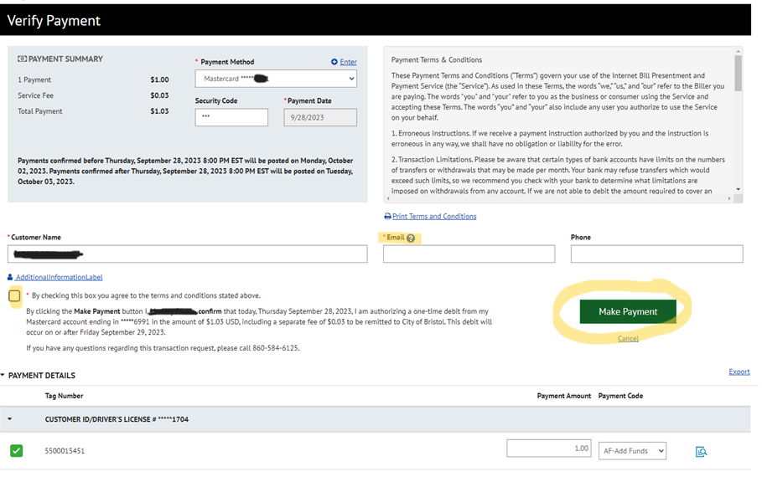
Confirmation of Payment
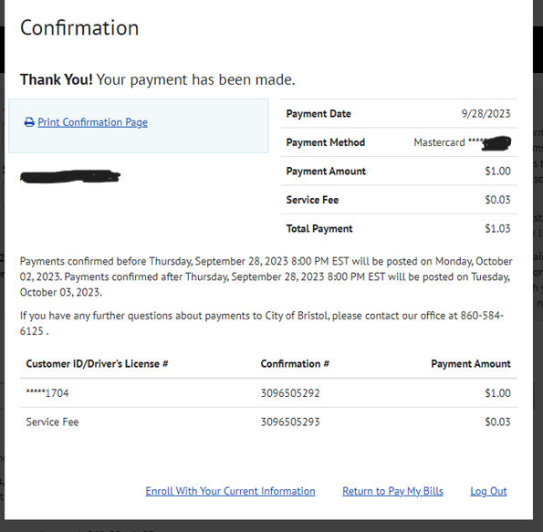
You will receive a confirmation email that looks like this:
